10/23/16 @ 10am
1262 Riverchase Blvd., Rock Hill, SC 29732
(803)810-9398 | illuminechurch.com
WORSHIP GUIDE
welcome to
WORSHIP
EXPECT

what to

The goal of worship at Illumine is that God would give you spiritual rest through prayer, preaching, and his Word. Everything that happens will revolve around a central concept. The service will last for 60-65 minutes.

- Restrooms are located in the pallet-wall hallway.
- There are rocking chairs for parents if you need to calm a child.
- Please fill out a connection card. It’s our best way to get people involved and plan ahead.
- The entire service is found in this booklet and on the screen. The written music for the songs is included on the following pages.
- There will be an offering today. This is primarily for the regulars – if you’re a guest, thanks for being here! It’s an honor to have you.

If you have any questions, don’t hesitate to ask. Everyone you see around you is working to accomplish the same goal – that we can all be served by hearing what God has to say. If we can take down barriers between you and that message, we will.

Thank you,

Kent Reeder, Pastor
(803)810-9398
kentr@illuminechurch.com

Show friends where you are – check in!
CURRENT SERIES INFO
OUR CURRENT SERIES

Series: LAW/GOSPEL
One of the most confusing, most misunderstood, and most important parts of following Jesus is understanding the difference between God's message of Law and his message of Gospel. People inside and outside of Christianity are consistently mixing these two teachings up, and it makes sense. Since the Garden of Eden, Satan has worked to make people misunderstand the love of a mighty God. It’s our hope that this series is just one helpful part of your lifelong journey toward clarity on these vital truths.

Focus: Law and/or Gospel
In God’s Law, he speaks and it becomes our work to carry out his command. In the Gospel, on the other hand, God speaks and then he does the work, carrying out his promises. These teachings are different, and as we’ve discussed in this series, meant to be separate.

Today, we’re asking if they need to be used together or if the two teachings can be used in isolation. Can we live in a Law-only world? Could we function in a Gospel-only world? Would a Christian be content with just one or the other, or is this a both/and scenario? The Law and Gospel are both gifts from God, and he has specific ways for us to use them – in particular, he wants us to use them together for our salvation.

PRAYER BEFORE WORSHIP

Jesus,

You Word inspires our hearts, and not just emotionally. Thank you for the spiritual encouragement and guidance that you’ve given us through the gift of the Bible.

Amen

OPENING PRAYER

Son of God, Eternal Savior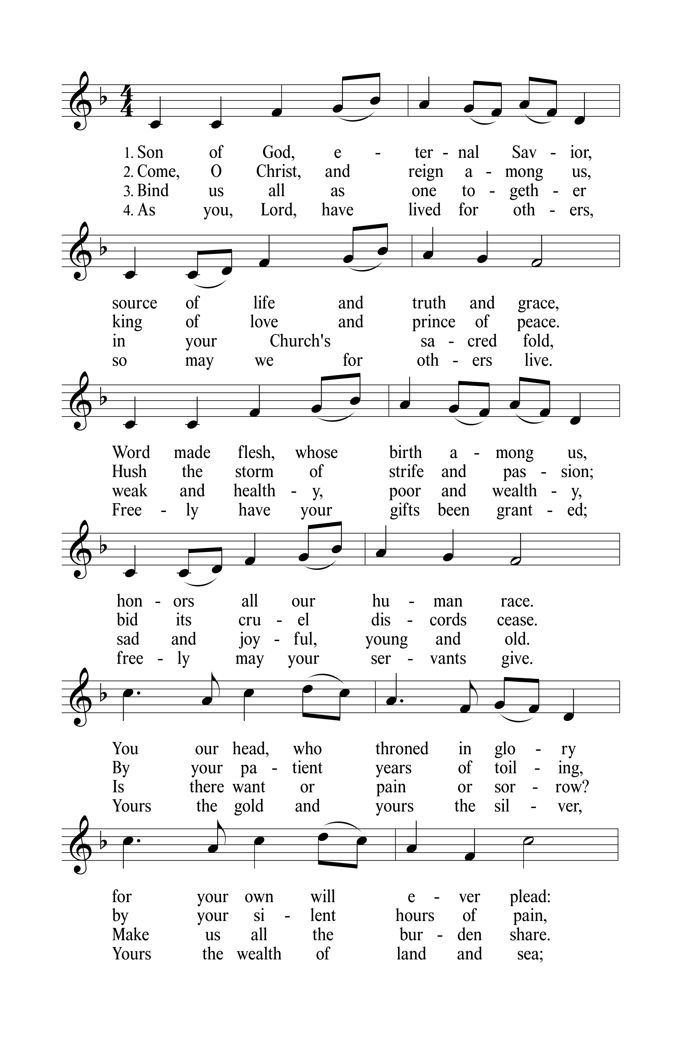
CONFESSION of SINS

1 John 3:1-8
- How great is the love the Father has lavished on us, that we should be called children of God!
- And that is what we are! The reason the world does not know us is that it did not know him.
- ² Dear friends, now we are children of God, and what we will be has not yet been made known.
- But we know that when he appears, we shall be like him, for we shall see him as he is.
- ³ Everyone who has this hope in him purifies himself, just as he is pure.
- ⁴ Everyone who sins breaks the law; in fact, sin is lawlessness.
- ⁵ But you know that he appeared so that he might take away our sins. And in him is no sin.
- ⁶ No one who lives in him keeps on sinning. No one who continues to sin has either seen him or known him.
- ⁷ Dear children, do not let anyone lead you astray. He who does what is right is righteous, just as he is righteous.
- ⁸ He who does what is sinful is of the devil, because the devil has been sinning from the beginning.
- The reason the Son of God appeared was to destroy the devil’s work.
- Lord, through Jesus you destroyed the devil’s work,
even the work we did in the devil’s service.
You have taken away our lawlessness
and given us your perfect obedience.
How great is your love? So great that you would call us your children.
Thank you for the gift of forgiveness.
In Jesus name: Amen.

Brokenness Aside

LAW and/or GOSPEL

Part 1: Law Without the Gospel?

Leviticus 18:1-5 | The Lord said to Moses, ² “Speak to the Israelites and say to them: ‘I am the Lord your God. ³ You must not do as they do in Egypt, where you used to live, and you must not do as they do in the land of Canaan, where I am bringing you. Do not follow their practices. ⁴ You must obey my laws and be careful to follow my decrees. I am the Lord your God. ⁵ Keep my decrees and laws, for the man who obeys them will live by them. I am the Lord.

Romans 10:5-13 | ⁵ Moses describes in this way the righteousness that is by the law: “The man who does these things will live by them.” ⁶ But the righteousness that is by faith says: “Do not say in your heart, ‘Who will ascend into heaven?’” (that is, to bring Christ down) ⁷ “or ‘Who will descend into the deep?’” (that is, to bring Christ up from the dead). ⁸ But what does it say? “The word is near you; it is in your mouth and in your heart,” that is, the word of faith we are proclaiming: ⁹ That if you confess with your mouth, “Jesus is Lord,” and believe in your heart that God raised him from the dead, you will be saved. ¹⁰ For it is with your heart that you believe and are justified, and it is with your mouth that you confess and are saved. ¹¹ As the Scripture says, “Anyone who trusts in him will never be put to shame.” ¹² For there is no difference between Jew and Gentile—the same Lord is Lord of all and richly blesses all who call on him, ¹³ for, “Everyone who calls on the name of the Lord will be saved.”

John 1:14-17 | ¹⁴ The Word became flesh and made his dwelling among us. We have seen his glory, the glory of the One and Only, who came from the Father, full of grace and truth.

¹⁵ John testifies concerning him. He cries out, saying, “This was he of whom I said, ‘He who comes after me has surpassed me because he was before me.’ ” ¹⁶ From the fullness of his grace we have all received one blessing after another. ¹⁷ For the law was given through Moses; grace and truth came through Jesus Christ.

Children’s Message | No Rules!?!

Alas, and Did My Savior Bleed

Part 2: I Want to See Jesus

John 12:20-33 | ²⁰ Now there were some Greeks among those who went up to worship at the Feast. ²¹ They came to Philip, who was from Bethsaida in Galilee, with a request. “Sir,” they said, “we would like to see Jesus.” ²² Philip went to tell Andrew; Andrew and Philip in turn told Jesus.

²³ Jesus replied, “The hour has come for the Son of Man to be glorified. ²⁴ I tell you the truth, unless a kernel of wheat falls to the ground and dies, it remains only a single seed. But if it dies, it produces many seeds. ²⁵ The man who loves his life will lose it, while the man who hates his life in this world will keep it for eternal life. ²⁶ Whoever serves me must follow me; and where I am, my servant also will be. My Father will honor the one who serves me.

²⁷ “Now my heart is troubled, and what shall I say? ‘Father, save me from this hour’? No, it was for this very reason I came to this hour. ²⁸ Father, glorify your name!”

Then a voice came from heaven, “I have glorified it, and will glorify it again.” ²⁹ The crowd that was there and heard it said it had thundered; others said an angel had spoken to him.

³⁰ Jesus said, “This voice was for your benefit, not mine. ³¹ Now is the time for judgment on this world; now the prince of this world will be driven out. ³² But I, when I am lifted up from the earth, will draw all men to myself.” ³³ He said this to show the kind of death he was going to die.

THANKS & PRAYER

Offering
Connection Cards & Prayer Requests
PayPal: illuminechurch@gmail.com

Prayer & The Lord’s Prayer
- Our Father in heaven, hallowed be your name.
Your kingdom come,
your will be done on earth as in heaven.
Give us today our daily bread. Forgive us our sins.
as we forgive those who sin against us.
Lead us not into temptation, but deliver us from evil.
For the kingdom, the power, and the glory
are yours now and forever. Amen.

Blessing
The Apostles Creed
- I believe in God, the Father almighty, maker of heaven and earth.
I believe in Jesus Christ, his only Son, our Lord,
who was conceived by the Holy Spirit,
born of the virgin Mary,
suffered under Pontius Pilate,
was crucified, died, and was buried.
He descended into hell.
The third day he rose again from the dead.
He ascended into heaven and is seated at the right hand of God the Father almighty. From there he will come to judge the living and the dead.
I believe in the Holy Spirit,
the holy Christian Church, the communion of saints, the forgiveness of sins, the resurrection of the body, and the life everlasting. Amen.
Lord, Open Now My Heart to Hear
Illumine is a confessional Lutheran congregation and a member of the
Wisconsin Evangelical Lutheran Synod, an international body of over 1,300 congregations.
ILLUMINE
this week @

Today
11:30am | Adult Bible Class & Kids Sunday School
Monday, October 24th
7pm | Small Group on CONFLICT @ the Center
Tuesday, October 25th
5pm | Confirmation Class @ the Center
6pm | Steering Committee Meeting @ the Center
6:30pm | Queen City DanceOut (3rd Party Rental)
Wednesday, October 26th
6pm | Illumine Academy & CLS @ the Center
7pm | Small Group on CONFLICT @ the Center
Thursday, October 27th
10am | Violin Lessons (3rd Party Rental)
6pm | BASICS Course – Final Lesson!
7:30pm | Music Practice
Saturday, October 29th
7am-12pm | Free Yard Sale @ the Center
Sunday, October 30th
10am | Law/Gospel part 5: Law before/after Gospel
11:30am | Adult Bible Class & Kids Sunday School
12pm | 5th Sunday Potluck (Theme: Oktoberfest)

Mark Your Calendars
Illumine Booth @ Ft. Mill Fall Fest | 10/31, 5-8pm

